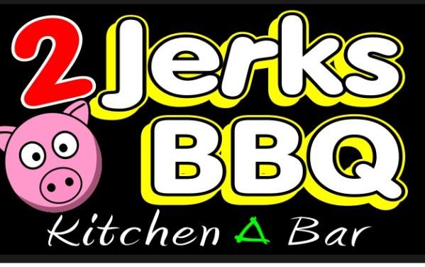  701 Broadway  Raynham, MA 02767  508-386-2737  www.facebook.com/2jerksbbq  Serving: Chicken Wings and Mac and Cheese | 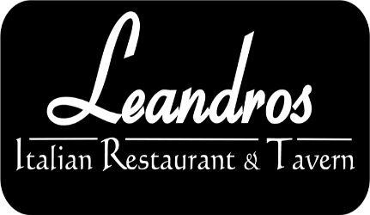  402 Turnpike Street  Easton, MA 02375  508-297-0366  http://www.leandrosrestaurant.com/  Serving: Short Ribs with Mashed Potatoes
120 Stockwell Drive  Avon, MA 02322  508-232-4016  www.costco.com  Serving: Cake | 375 Central St  Foxborough, MA 02035  508-543-8283  Serving: Chocolate Dipped Strawberries, Apple Wedges, and PIneable
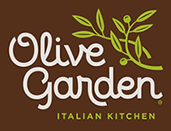  Olive Garden- Patriot Place  392 Patriot Place  Foxborough, MA 02035  508-543-3967  Serving: Lasagna and Five-cheese Ziti Al forno | Montilio's Baking Co.  134 Spark Street  Brockton, MA 02302  508-894-8855  www.montilios.com  Serving: Desserts
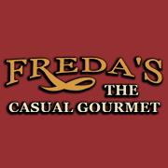  105 Copeland St.  West Bridgewater, MA 02379  508-583-8217  http://www.fredasrestaurant.com/home.aspx  Serving: Casual Gourmet Food | Piezoni’s  25 Robert Dr.  South Easton, MA 02375  508-230-5888  Serving: Pizza
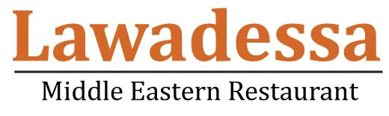  Lawadessa  757 West Center Street  W. Bridgewater, MA 02379  508-510-6315  http://www.lawadessarestaurant.com/  Serving: Hummus, Grape leaves, Falafel | Mario’s Trattoria  260 Washington Street  North Easton, MA 02356  508-238-9288  http://www.mariostrattoria.net/  Serving: Meatballs, Arancini, Chicken Parm
Papa Ginos  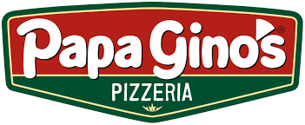  Plymouth Crossing  594 Washington Street.  South Easton, MA02375  508-238-0118  Serving: Buffalo, Garlic & Cheese, Cheddar & Bacon breadstick flavors | Petti’s Market & Deli  216 Belmont Street  Brockton, MA 02301  508-586-6210  http://www.pettismarket.com/  Serving: Italian Sausages, Chinese sausages, rolls
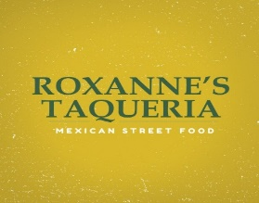  Roxanne’s Taqueria  3 Roche Brothers Way  Easton, MA 02356  508-297-0277  http://roxannestaqueria.com/  Serving: Mini Mexican Bowl | Stoneforge Grille  10 Roosevelt Circle  South Easton, MA 02375  508-238-0550  Serving: Brisket & Cole Slaw
Simpson Springs  Washington Street  South Easton, MA 02375  508-4472  Serving: Handmade Soda and Water | 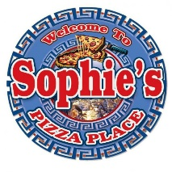  Sophie’s Pizza Palace  479 Turnpike Street  South Easton, MA 02375  508-238-3666  Serving: Pizza
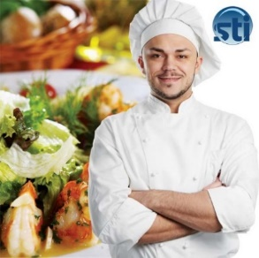  Southeastern Technical Institute  Adult Culinary Arts Program  250 Foundry Street South Easton, MA 02356  508-230-1297 http://stitech.edu/  Serving: Lobster Mac & Cheese w/ poblano pepper cheese sauce, Jamon Serrano cured ham Spanish style w/ blue cheese and green apple | SERSD – Culinary Arts Department  250 Foundry Street S. Easton, MA 02356  508-230-1458 https://www.sersd.org/community/colonial-room-restaurant/  Serving: Chicken Broccoli Ziti, Cupcakes, Chocolate & Carrot Cake

